OPP LAB TASK

**LAB TASK #10**

**Activity 1:**

**C++ program to demonstrate the working of friend function. Source Code:**

**#include <iostream> using namespace std;**

**class Distance**

**{**

**private:**

**int meter; public:**

**Distance(): meter(0) { }**

**// public accessor function int getMeter()**

**{**

**return meter;**

**}**

**// friend function**

**friend int addFive(Distance);**

**};**

**// friend function definition int addFive(Distance d)**

**{**

**d.meter += 5;**

**return d.getMeter();**

**}**

**int main()**

**{**

**Distance D;**

**cout<<"Distance: "<< addFive(D); return 0;**

**}**

OUTPUT:

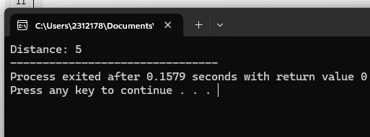

**Activity #2: Source Code:** #include <iostream> using namespace std;

// forward declaration class B;

class A { private:

int numA; public:

A(): numA(12) { }

// friend function declaration friend int add(A, B);

};

class B { private:

int numB; public:

B(): numB(1) { }

// friend function declaration friend int add(A, B);

};

int add(A a, B b)

{

return (a.numA + b.numB);

}

int main()

{

A objectA;

B objectB;

cout<<"Sum: "<< add(objectA, objectB); return 0;

}

**OUTPUT:**

